3.

import java.util.Scanner;

class Complex{

public static void main(String[] args){

int realSum,ImgSum;

Scanner sc = new Scanner(System.in);

System.out.println("Enter the real part of complex no 1:");

int real1=sc.nextInt();

System.out.println("Enter the imaginary part of complex no 1:");

int imaginary1=sc.nextInt();

System.out.println("First complex no is:"+real1+"+"+imaginary1+"i");

System.out.println("Enter the real part of complex no 2:");

int real2=sc.nextInt();

System.out.println("Enter the imaginary part of complex no 2:");

int imaginary2=sc.nextInt();

System.out.println("Second complex no is:"+real2+"+"+imaginary2+"i");

realSum=real1+real2;

ImgSum=imaginary1+imaginary2;

System.out.println("sum of complex no is:"+realSum+"+"+ImgSum+"i");

}

}

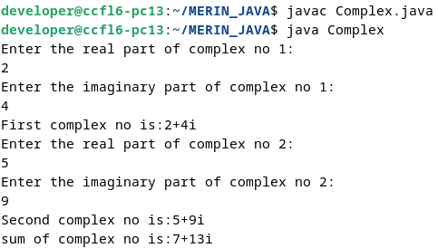

7.

import java.util.Scanner;

class Employee{

int eNo;

String eName;

int eSalary;

Employee(int eNo,String eName,int eSalary){

this.eNo=eNo;

this.eName=eName;

this.eSalary=eSalary;

}

public void printDetails(){

System.out.println("Employee Details:");

System.out.println("ENO:"+this.eNo+",ENAME:"+this.eName+",ESALARY:"+this.eSalary);

}

}

class Main2{

public static void main(String[] args){

Scanner sc = new Scanner(System.in);

System.out.print("Enter number of Employees:");

int n=sc.nextInt();

Employee emp[]=new Employee[n];

for(int i=0;i<n;i++){

System.out.print("Enter NO: ");

int eNo=sc.nextInt();

sc.nextLine();

System.out.print("Enter NAME: ");

String eName=sc.nextLine();

System.out.print("Enter SALARY: ");

int eSalary=sc.nextInt();

sc.nextLine();

emp[i]=new Employee(eNo,eName,eSalary);

}

System.out.print("Enter number to search:");

int SearchNo=sc.nextInt();

for(int i=0;i<n;i++){

if (emp[i].eNo == SearchNo) {

emp[i].printDetails();

break;

}

}

}

}

